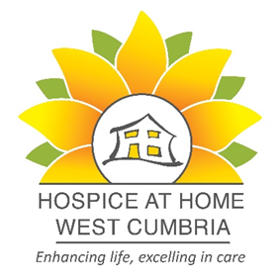

Are you looking for a new challenge and the opportunity to make a real difference within your local community?
Hospice at Home West Cumbria is a “hospice without walls” providing home nursing, lymphoedema care, family and bereavement support and complementary therapies to patients, families, and carers across West Cumbria. Hospice at Home West Cumbria works alongside and in collaboration with the other providers of specialist palliative care, i.e., clinical nurse specialists, medical team, occupational therapy, and The Loweswater Suite.
Hospice at Home West Cumbria is seeking enthusiastic, committed, and motivated registered nurses and health care assistants with excellent communication skills to join their home nursing team. Candidates should be passionate about delivering high quality palliative and end of life care, to patients and families living with life limiting illness.
The following vacancies are available within the home nursing team:
- Registered General Nurses - Annualised hours contract (maximum 17 hours) and flexible hours contract
- Health Care Assistants – Annualised hours contract (maximum 17 hours) and flexible hours contract
Please refer to job description for full details of role and responsibilities.
Consideration will only be given to candidates who meet the personal specification criteria, please specify in your application which contract you are interested in.
For an informal discussion please telephone Christina Nicholson, Home Nursing & Lymphoedema Team Lead on 01900 705200.

Apply via our website www.hospiceathomewestcumbria.org.uk or call
01900 705200 for an application pack
Closing date: open recruitment
Interview date: to be confirmed
Registered charity number 1086837

